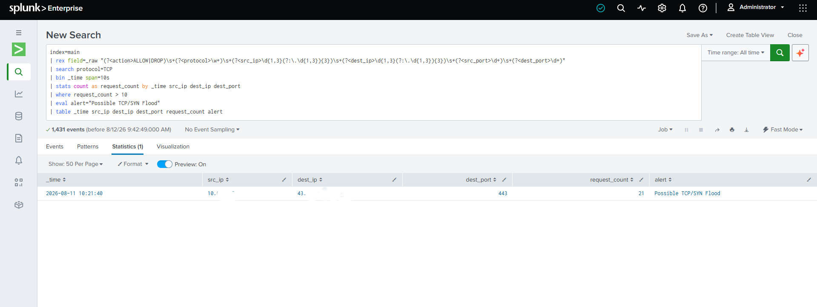

🔐 SOC L1 Detection Lab — TCP SYN Flood Detection with Splunk
📌 Project Overview
Built a controlled SOC L1 lab to detect suspicious TCP/SYN traffic using Kali Linux, Windows 10, Splunk Universal Forwarder, and Splunk Enterprise.
The lab demonstrates the complete detection workflow:
Kali → Windows Firewall → Splunk Universal Forwarder → Splunk Enterprise → Detection Alert 🚨
🎯 Objective
Detect more than 10 TCP requests from the same source IP within a 10-second window using Splunk SPL.
🛠️ Tools & Technologies
- Kali Linux — Traffic generation
- Windows 10 — Target system & Firewall logs
- Splunk Universal Forwarder — Log collection
- Splunk Enterprise — SIEM & detection
- SPL — Search and detection logic
- Virtual Machines — Isolated lab environment
🔎 Detection Logic
index=main TCP
| bin _time span=10s
| stats count as tcp_count by _time src_ip dest_ip
| where tcp_count > 10
| sort - tcp_count
This detection:
- Groups events into 10-second windows
- Counts TCP requests
- Groups activity by source and destination IP
- Triggers when the request count exceeds the threshold
📊 SOC L1 Skills Practiced
- SIEM log ingestion
- Windows Firewall monitoring
- Splunk Universal Forwarder
- SPL searching
- Field extraction
- Threshold-based detection
- Alert creation
- Network traffic analysis
- Basic alert investigation
- False-positive analysis
📸 Screenshots
The screenshots/ folder contains:
- Lab setup/topology
- Kali traffic generation
- Windows Firewall logs
- Splunk indexed events
- SPL detection results
- Splunk alert
📁 Repository Structure
splunk-tcp-syn-flood-detection/
│
├── README.md
├── screenshots/
├── spl/
│ └── syn_flood_detection.spl
├── firewall-logs/
│ └── sample-pfirewall.log
└── documentation/
└── lab-setup.md
⚠️ Disclaimer
This project was performed in an isolated, authorized cybersecurity lab using virtual machines. Traffic generation was conducted only against systems controlled for testing.
🚀 Future Improvements
- SYN-specific detection
- Threat intelligence enrichment
- MITRE ATT&CK mapping
- Splunk dashboard
- Improved false-positive reduction
- Additional network detection rules

